Booking system of the AEM animal facility

It is based on a Google account.
You can access it at: http://www.gmail.com
Login: aemrodents@gmail.com
The password is changed occasionally and is posted on the webpage: https://emed.ku.dk/documents/book-a-procedure-room/ (remember the dot at the end of the password)

How to book a procedure room
- Log into the gmail account.
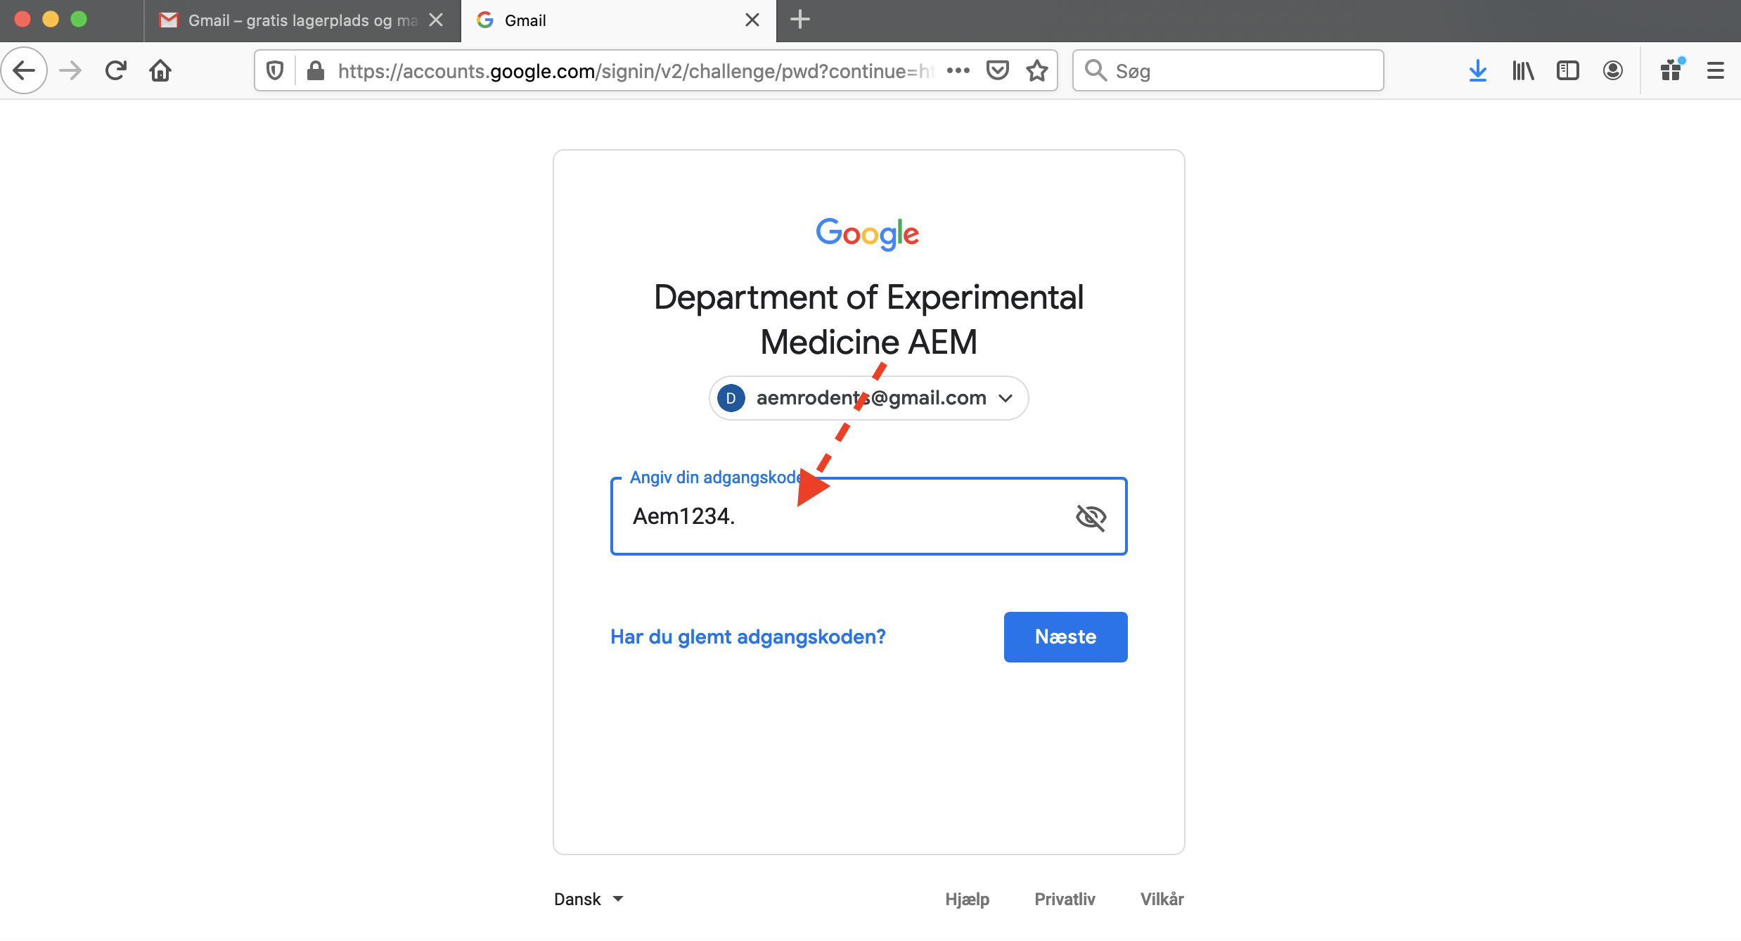
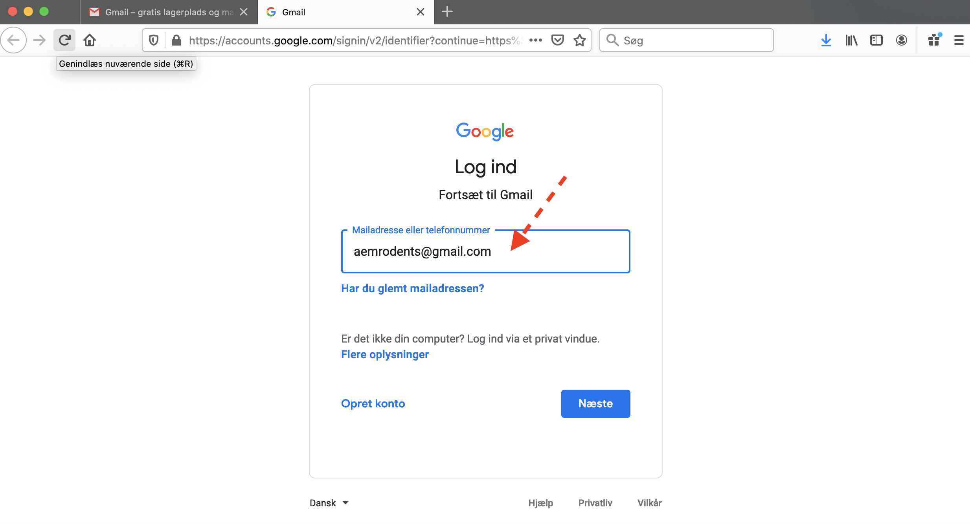
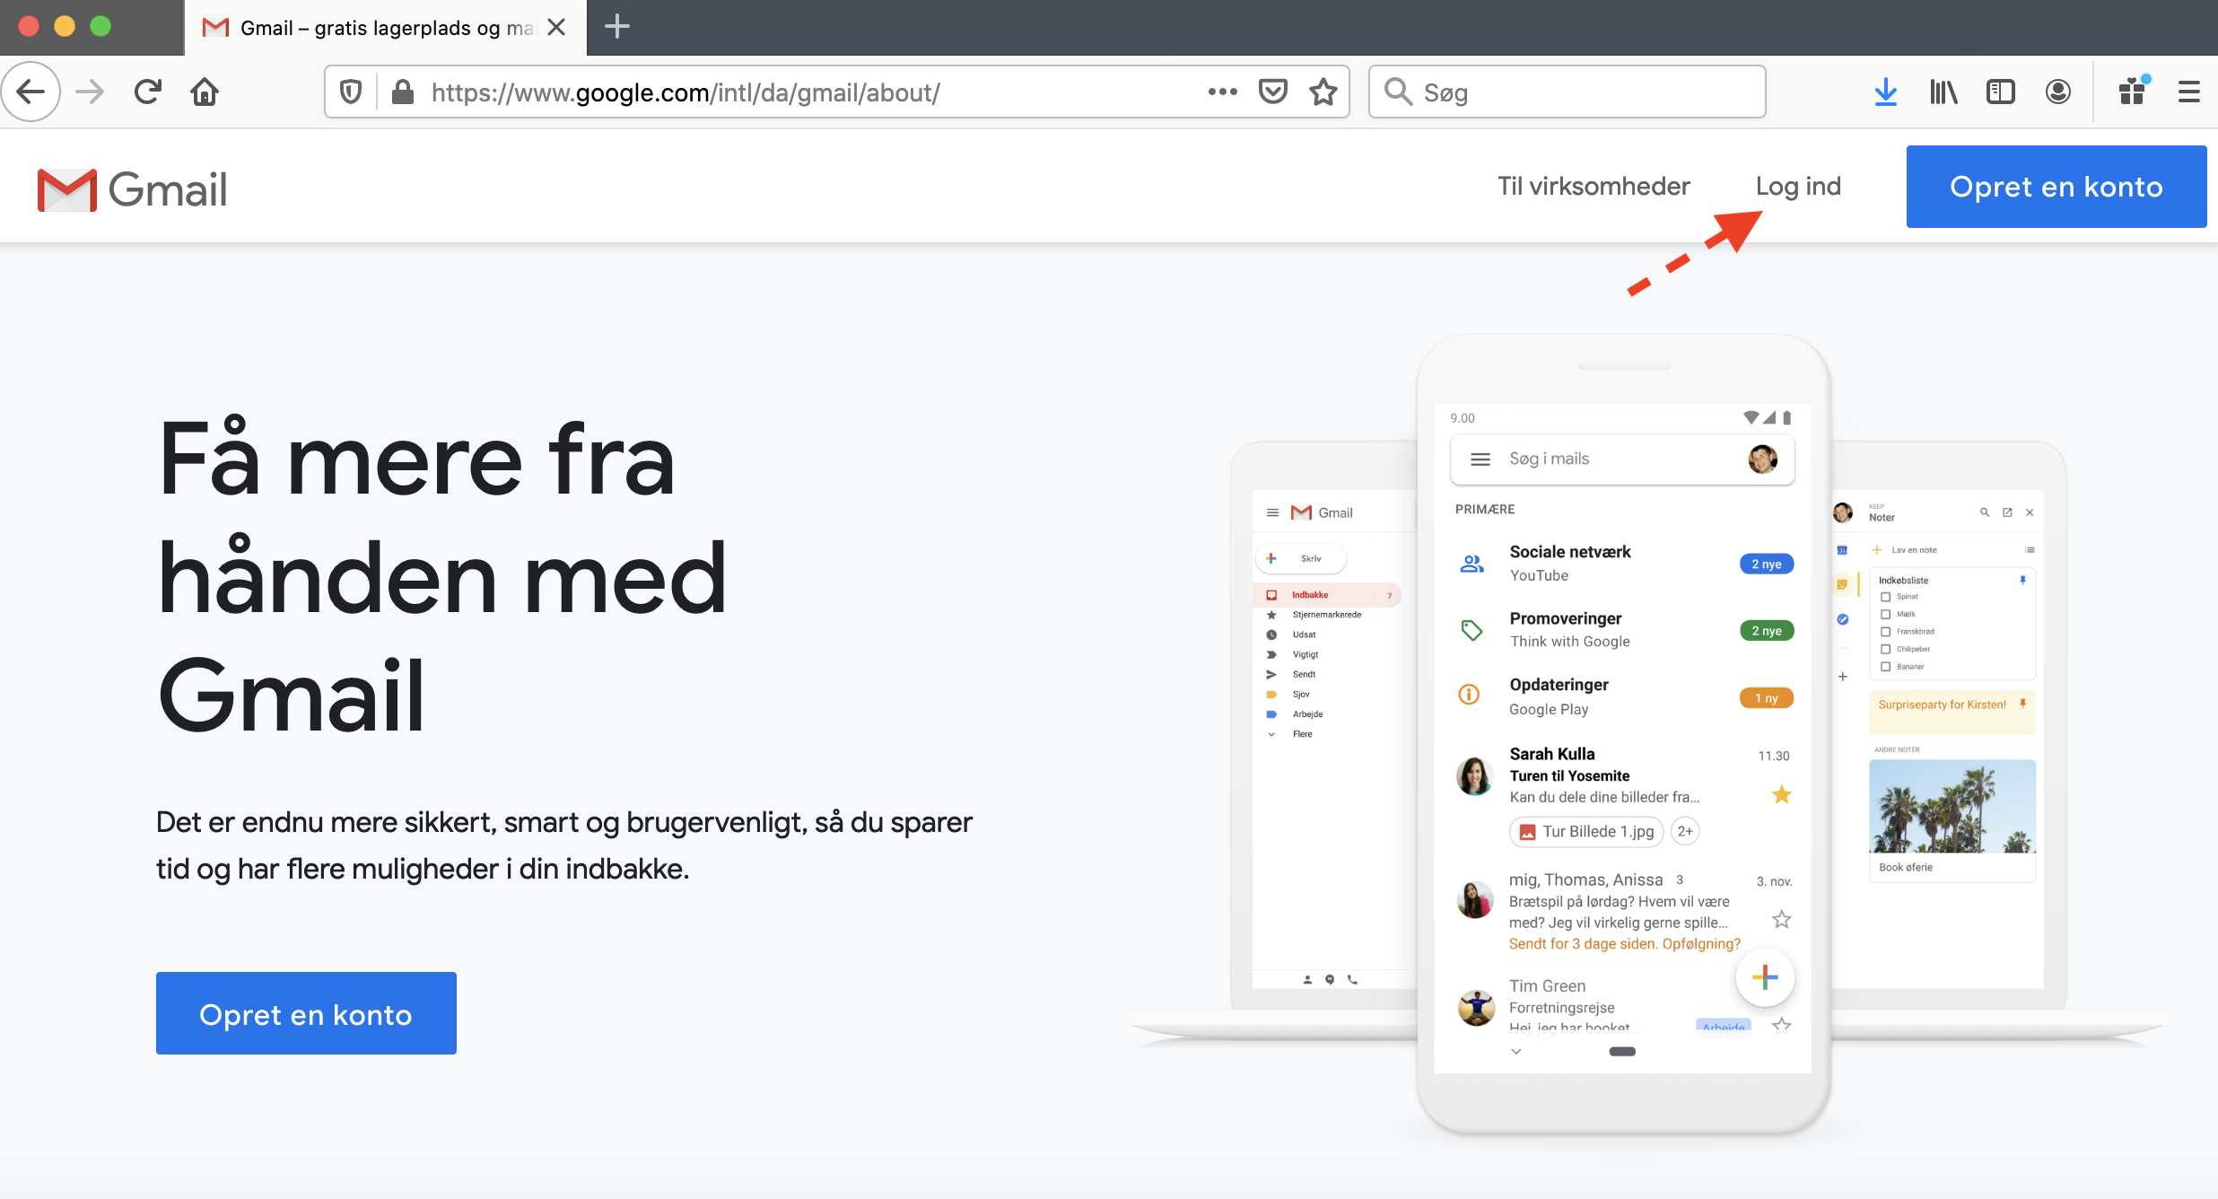

- In the right part of the tool bar, click on the symbol with the little squares and select “Calendar”.
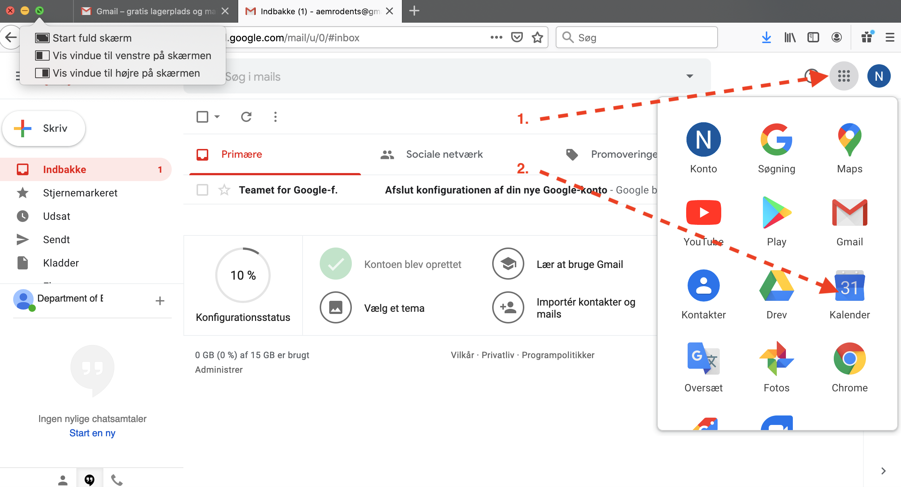

A new window will open with different calendars to the left indicating the procedure rooms at the different units.
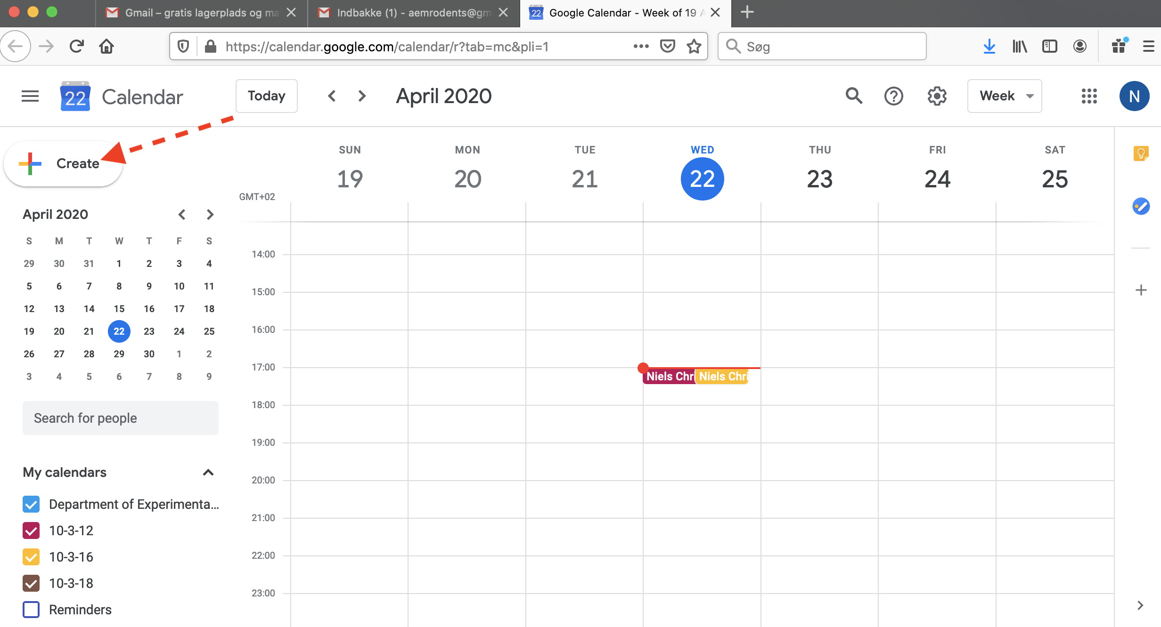
- To make a new booking, click on “Create”.

- Under “Add title” PLEASE INDICATE YOUR NAME AND PHONE NUMBER AND/OR E-MAIL. Under “Add description” please indicate if you can share the room or if you need the room for yourself. Select the day, hours you want to book and finally the relevant room*. Press “Save” to save the booking.
* Note that some rooms can be shared because of size in the Biocenter mainly. Book the functions you need. If you cannot share, please book all functions in the room.

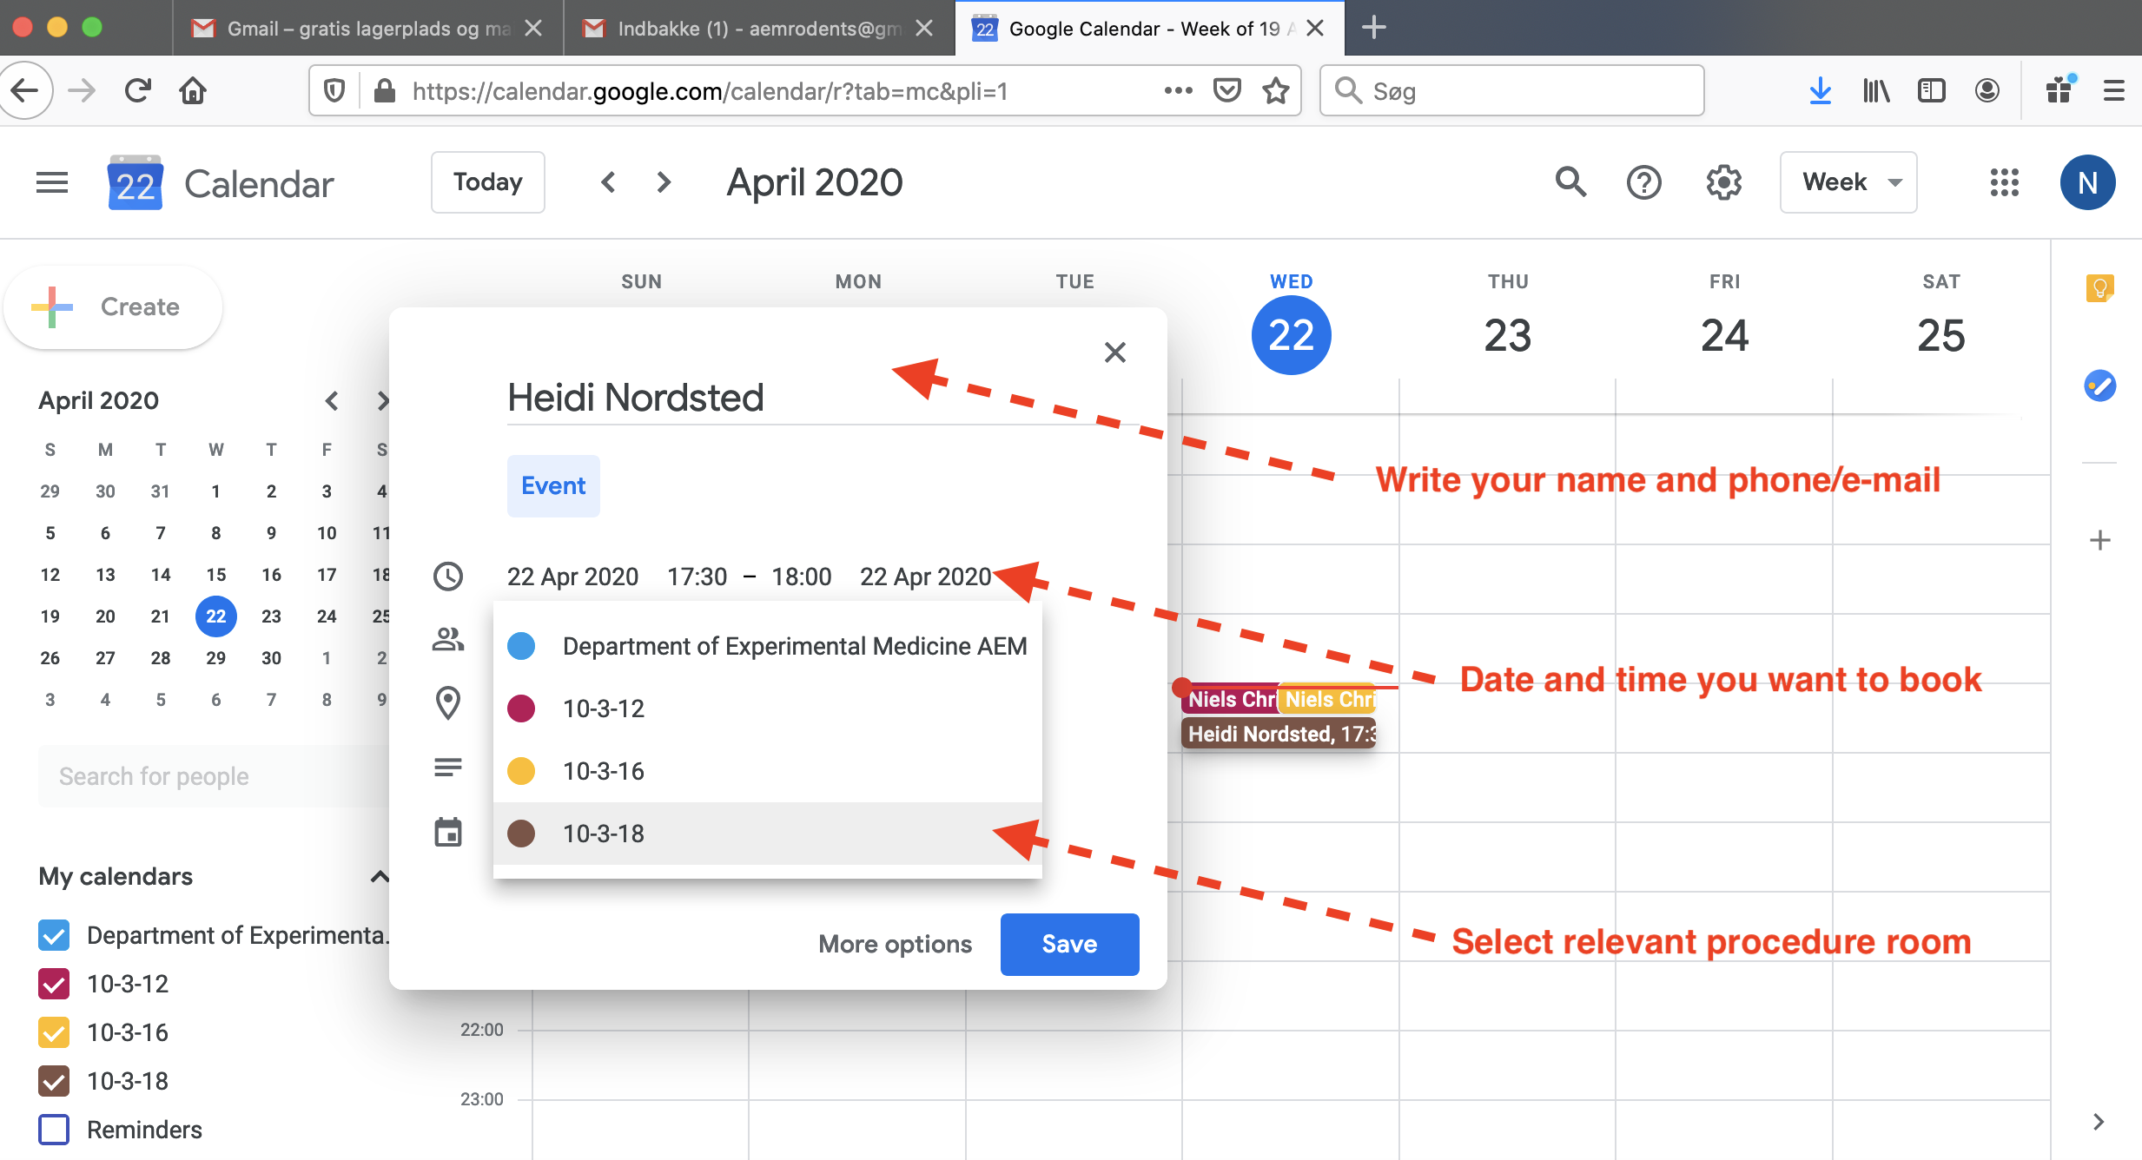

Rules
- You cannot delete other people’s bookings unless you have an agreement with the relevant person.
- If a person is delayed for more than 15 minutes the booking is cancelled.
- If you finish earlier, please update your booking.
- The gmail account is administered by Niels Christian Kampmann, chka@sund.ku.dk; 30291266.

